Expense Ticket Reimbursement
- All expense must be submitted by Tuesday at 12:00 PM EST to be considered for payment the same week
- All expenses will be paid via ACH (If you update your bank account with payroll you MUST contact Accounts Payable as well. We do not share systems)
- We pay once a week

- SharePoint
- Click on the Finance Option
- Expense Report Forms
- Click on the “NEW” button to create new expense ticket
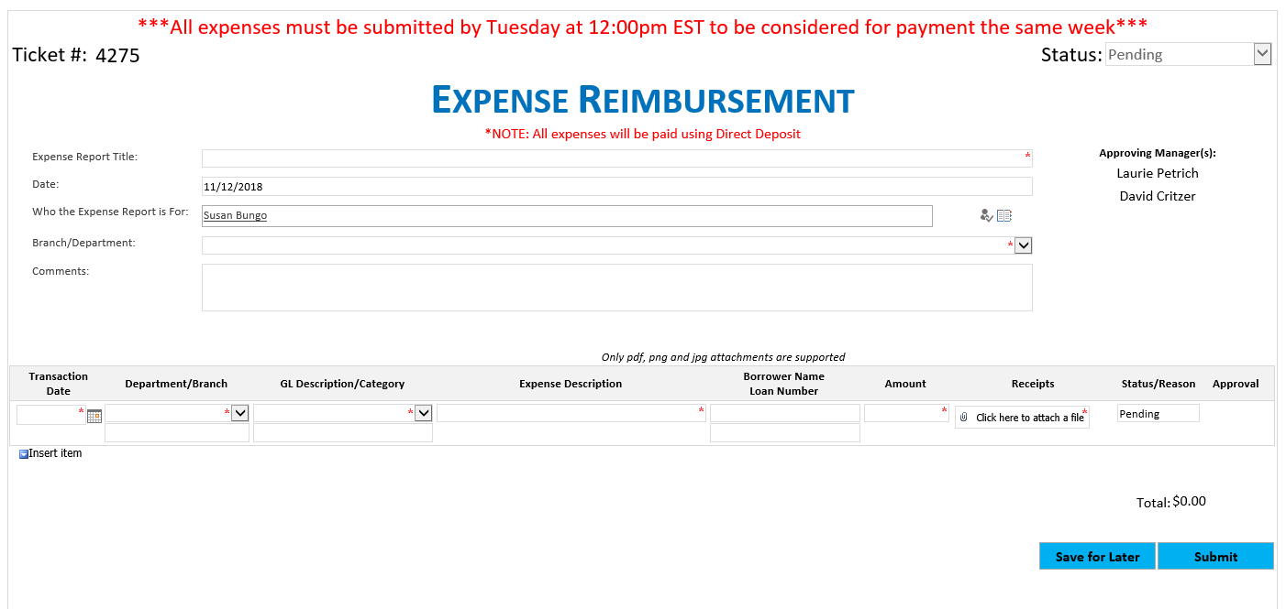
- Expense Report Title: This is where you create a name for the report (Travel expenses, Meetings, Inspections, etc.)
- Date: Auto populates to today’s date
- Who the expense report is for: Who paid for the expense and is getting reimbursed
- Branch/Department: Your cost center where the charges are applied to
- Comments: If there are any special notes to help us approve the expenses
- Transaction Date: Date of the expense
- Department/Branch: This will auto populate based on what you chose above
- Expense Description: What was the expense for? Meals (who the meals were for), Travel, Training, Inspections, etc.
- Borrower Name/Loan Number: If this expense was for a loan
- Amount: Amount of expense
- Receipts: Must attach a copy of the receipt for IRS purposes

If you have more than one expense, please click on the “INSERT ITEM” button and add your next expense.

