1. Milestones are completed in the following steps:
   * File Started
   * Qualification
   * Application
   * Sent to processing (Need completed 1003 uploaded to the 1003 e-folder, the 1003 we send to the end lender).
   * Process open finished (file will sit here till we have a Clear to close from lender)
2. Trigger application in encompass & submit a full package to investor with encompass 3.2 file, (File must be disclosed by end lender within 3 days of triggering application.)
3. Disclose 1003 & all State docs required through encompass.
4. Receive initial docs from lender, upload them to the broker initial signed docs e-folder. ***These don’t need to be signed by borrower, just need a copy of lenders initial docs.***

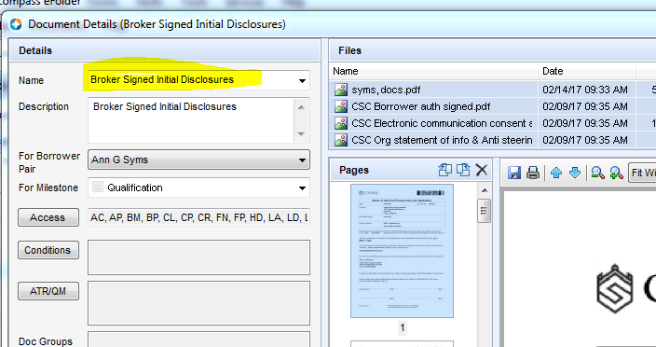

Once uploaded email Jon Sopko to move the file and make an entry into disclosure tracking so we can show file was disclosed and it doesn’t get closed out.

*** Timing is everything. Our file must match the lenders dates they disclosed, must be within 3 days of submitting application to Lender.

1. Docs need to be uploaded to the file before completing milestone to send to doc prep.

* Signed 1003 & All State disclosures from encompass
* Approval
* Rate Lock
* Clear to close
* Final CD

Once all these docs are uploaded you email Jon Sopko. He will review and complete the doc prep milestone, unless docs are needed he will email the processor or LO.

**You will not get paid unless all documents above are uploaded to the file..**

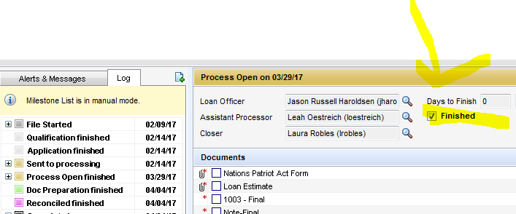

Reconciled milestone: Taylor will upload the check and deposit check once I give the ok all docs are in the file.

**Banked loans that don’t qualify CANNOT be moved to the broker channel. They must be denied in the banked channel and started over in the broker.**

To pull Broker Initial Disclosures directly from Encompass, follow these steps:

1. Start a new loan in the prospects folder. Click on New Loan icon.
   1. In the Public Loan Templates, select the Companywide folder
   2. In the Companywide folder, select Broker Template Sets
   3. Select Broker Purchaser or Refinance Application template

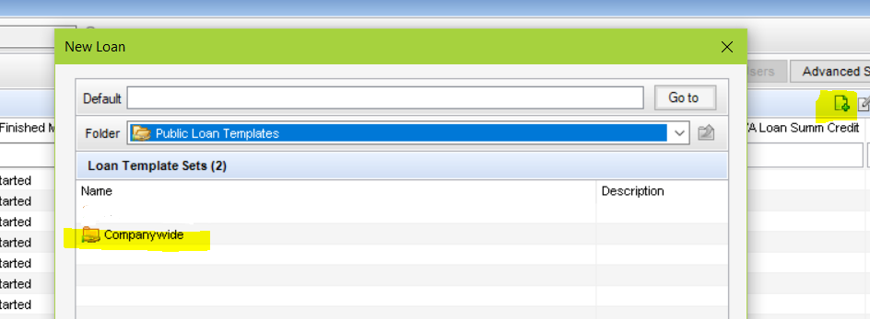

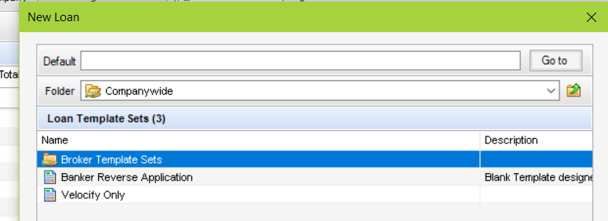

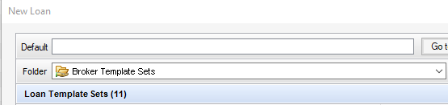



1. Complete the file with the appropriate data.
2. Click on the eFolder button then click the eDisclsoures button.





1. Select your plan code then click on Order eDisclosures

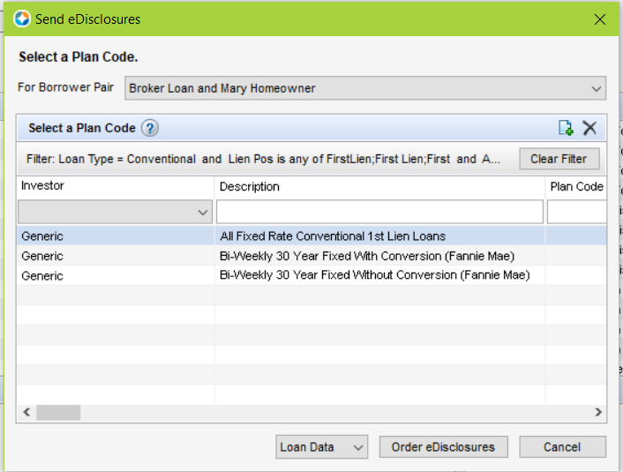

1. Complete any required data if applicable then click on Order eDisclosures

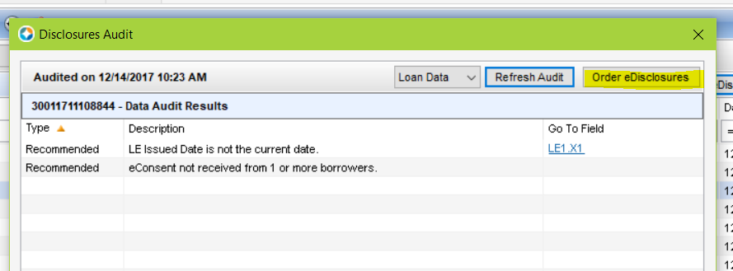

1. When the *Select Documents* window is presented

with the list of disclosures, click the ***Add to eFolder***

button.

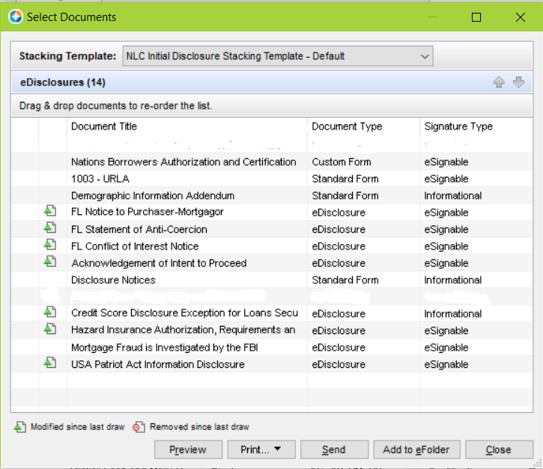

1. In the *Add Documents to eFolder* window, select the

***Add each document as a separate eFolder***

***attachment*** option, click ***OK***, and then click *OK*

again in the *Encompass Docs* window.



1. Close the *Select Documents* window and open the

*Background Attaching* conversion window by

clicking the icon at the bottom right of the

Encompass window.



1. In the *Background Attaching* window, scroll to the

bottom and insure the Conversion Progress and

Upload Progress for all documents are showing

100% before proceeding to the next step.



**Note: If all documents are not fully converted and**

**uploaded, the process will fail.**



1. Go to the *DocuSign Disclosure Request* input form

and click the ***Send documents to DocuSign*** button.

This will auto-save the loan.





1. After the loan is saved, the *Documents to be*

*delivered* window will be presented. Select *Initial*

*Disclosure* from the drop down. A list of disclosures

to be sent will populate. Click the ***Send*** button.

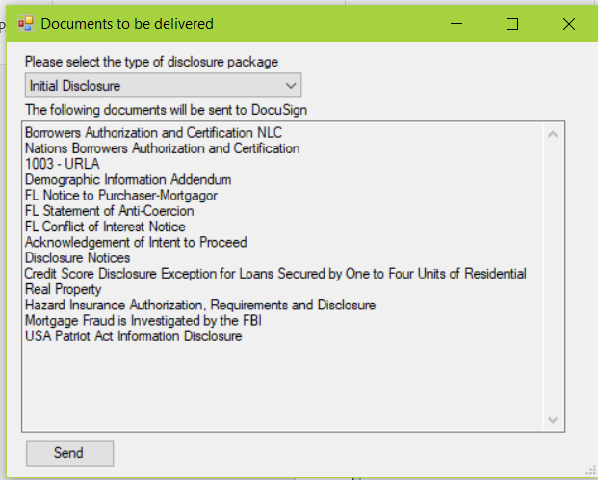

1. An Attachment Verification box will be presented to

confirm all document attachments were found.

Click ***OK***.



1. The pop up box below shows the Disclosure

Tracking timeline event is being added and the loan

is being auto-saved once again.



1. The document status will update as the input form

is refreshed and actions are taken within the

DocuSign portal. Be sure to confirm all expected

documents appear in the File Status section.



1. Go to your email and click the link to take you to DocuSign.
   1. Follow the instructions on DocuSign's Site to complete your signing.
   2. Note: Once you have completed your signing it will go to borrower 1 and after they complete it will go to borrower 2.



Once everyone has completed signing you will get an email letting you know that everyone has completed the signing process.