HOW TO SUBMIT A VENDOR REQUEST

Where to locate Vendor Requests on Loop:

Go to Loop. Choose Compliance

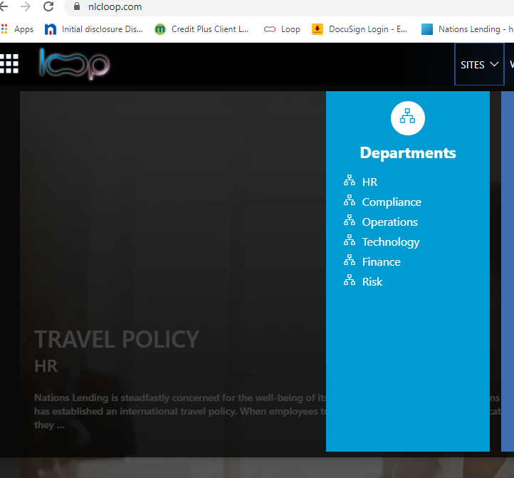

From here, choose Vendor Request/MSA & Co-Marketing Requests

Next, you will click on the link under the Vendor Requests Column. This link (reads as CLICK HERE) will take you to the main screen of the Vendor Management site where you will input your request for a new vendor.

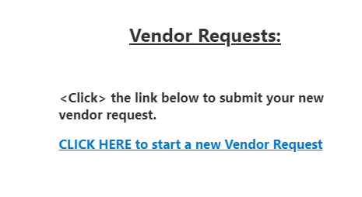
Click on New.
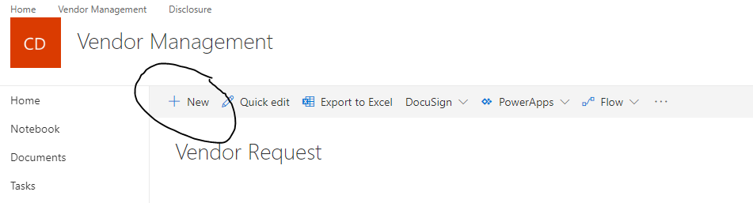

You will then see the below screen. Make sure you fill in all the fields that have a red asterisk as they are required fields or the site will not allow you to proceed if any of these fields are not completed.

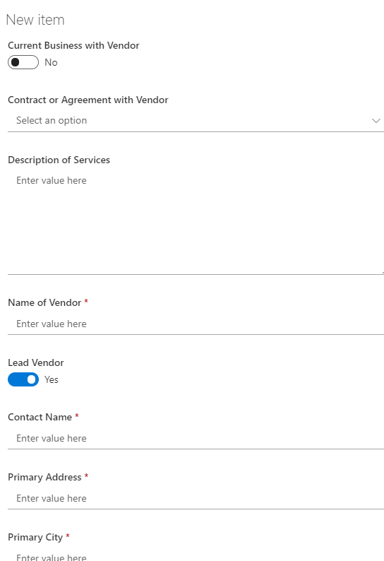

At the bottom of the input screen, you will have the option to add any attachments that you feel are beneficial to vet the vendor. Also, this is where you will save the information you have inputted. Hit SAVE once you are finished.

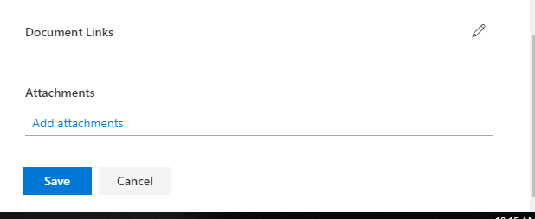

Once this is completed your vendor will be reviewed for a tier rating. Once the tier rating has been assigned the vendor will be contacted to complete the tier level vetting assigned to them. Enclosed is a cheat sheet for tiers.

