Co-Marketing/Co-Branding Procedures
For Nations to co-market with a realtor or a realty company, a Co-Marketing Agreement must be in place. To do this, the NLC employee will need to complete the Co-Marketing Form that is in Loop under the Compliance Site.

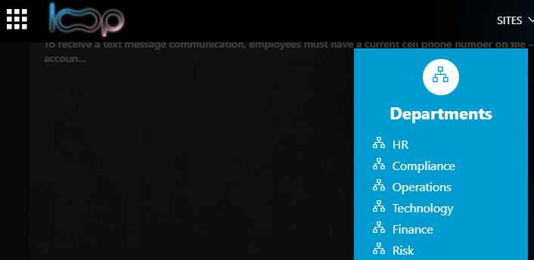

-From here, you will choose the Vendor Request/MSA & Co-Marketing Requests:
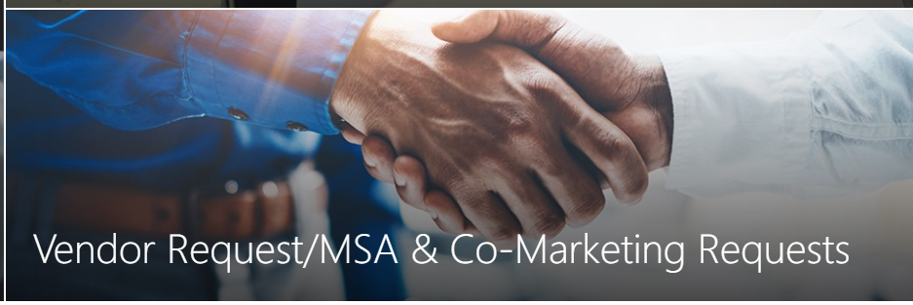

-Once on this page, you will choose Co-Marketing/Co-Branding Requests.
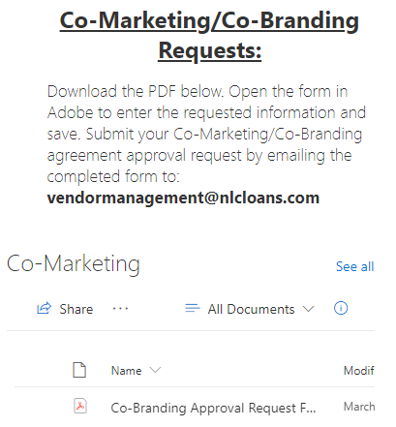

- Click on Co-Branding Approval Request Form and fill out the fields. (Short example of the form below)
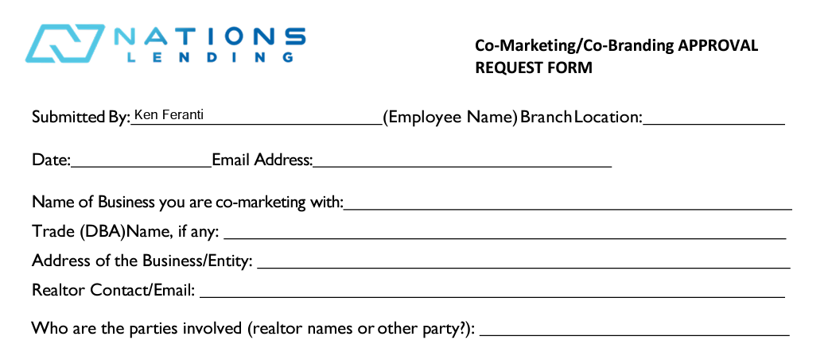

-Once this form is completed, you will email the completed form to vendormanagement@nlcloans.com .

